Batch: A2 Roll No.: 16010122034

Experiment / assignment / tutorial No.05
Grade: AA / AB / BB / BC / CC / CD /DD

Signature of the Staff In-charge with date

TITLE :Vector

AIM: Create a class Employee which stores E-Name, E-Id and E-Salary of an Employee. Use class Vector to maintain an array of Employee with respect to the E-Salary. Provide the following functions
1) Create (): this function will accept the n Employee records in any order and will arrange them in the sorted order.
2) Insert (): to insert the given Employee record at appropriate index in the vector depending upon the E-Salary.
3) delete ByE-name( ): to accept the name of the Employee and delete the record having given name
4) deleteByE-Id ( ): to accept the Id of the Employee and delete the record having given E-Id.

Provide the following functions
- boolean add(E e) : This method appends the specified element to the end of this Vector.
- void addElement(E obj) This method adds the specified component to the end of this vector, increasing its size by one.
- int lastIndexOf(Object o, int index) This method returns the index of the last occurrence of the specified element in this vector, searching backwards from index, or returns -1 if the element is not found.
- void removeElementAt(int index)This method deletes the component at the specified index.
______________________________________________________________________
Expected OUTCOME of Experiment:
CO2: Explore arrays, vectors, classes and objects in C++ and Java.
_____________________________________________________________________
Books/ Journals/ Websites referred:
- Ralph Bravaco , Shai Simoson , “Java Programming From the Group Up” Tata McGraw-Hill.

2.Grady Booch, Object Oriented Analysis and Design .
__________________________________________________________
Pre Lab/ Prior Concepts:

Vectors in Java are one of the most commonly used data structures. Similar to Arrays data structures which hold the data in a linear fashion. Vectors also store the data in a linear fashion, but unlike Arrays, they do not have a fixed size. Instead, their size can be increased on demand.
Vector class is a child class of AbstractList class and implements the List interface. To use Vectors, we first have to import Vector class from java.util package:
import java.util.Vector;
Access Elements in Vector:
We can access the data members simply by using the index of the element, just like we access the elements in Arrays.
Example- If we want to access the third element in a vector v, we simply refer to it as v[3].
Vectors Constructors
Listed below are the multiple variations of vector constructors available to use:
- Vector(int initialCapacity, int Increment) – Constructs a vector with given initialCapacity and its Increment in size.
- Vector(int initialCapacity) – Constructs an empty vector with given initialCapacity. In this case, Increment is zero.
- Vector() – Constructs a default vector of capacity 10.
- Vector(Collection c) – Constructs a vector with a given collection, the order of the elements is same as returned by the collection’s iterator.
There are also three protected parameters in vectors
  - Int capacityIncrement()- It automatically increases the capacity of the vector when the size becomes greater than capacity.
  - Int elementCount() – tell number of elements in the vector
  - Object[] elementData() – array in which elements of vector are stored

Memory allocation of vectors:

Vectors do not have a fixed size, instead, they have the ability to change their size dynamically. One might think that the vectors allocate indefinite long space to store objects. But this is not the case. Vectors can change their size based on two fields ‘capacity’ and ‘capacityIncrement’. Initially, a size equal to ‘capacity’ field is allocated when a vector is declared. We can insert the elements equal to the capacity. But as soon as the next element is inserted, it increases the size of the array by size ‘capacityIncrement’. Hence, it is able to change its size dynamically.
For a default constructor, the capacity is doubled whenever the capacity is full and a new element is to be inserted.

Methods of Vectors :
- Adding elements
- Removing elements
- Changing elements
- Iterating the vector

Class Diagram:

Employee
e_name:String
e_id:int
e_salary:int
Employee(String name, int id, int salary)
create(int num):Vector
insert(Vector<Employee> v, Employee e):Vector
delete_by_name(Vector<Employee> v, String name):String
delete_by_id(Vector<Employee> v, int id):String
sort_vector(Vector<Employee> v)
add(Vector<Employee> v, Employee e):boolean
addElement(Vector<Employee> v, Employee e)
lastIndexOf(Vector<Employee> v, Employee e):int
removeElementAt(Vector<Employee> v,int index)
Algorithm:
- Start
- Input number of employees to store in vector.
- Create records of employees by taking input of the name, id and salary of each employee from the user
- Sort the vector using selection sort
- Insert a new record into the ordered vector
- Display the list of employees
- Delete record using employee name
- Display the list of employees
- Delete record using employee id
- Display the list of employees
- End

Implementation details:
import java.util.*;

public class Employee{
String e_name;
int e_id;
int e_salary;

Employee(String name, int id, int salary){
e_name = name;
e_id = id;
e_salary = salary;
}

public static void main(String[] args){
Scanner sc = new Scanner(System.in);

System.out.println("Input the number of employee records to be added upto creation: ");
int num = Integer.parseInt(sc.nextLine());
Vector<Employee> e_vec = Employee.create(num);

Employee.sort_vector(e_vec);

System.out.println("\n###\nInput the details of a new employee:");
System.out.println("Enter their name: ");
String name = sc.nextLine();

System.out.println("Enter their ID number: ");
int id = Integer.parseInt(sc.nextLine());

System.out.println("Enter their Salary: ");
int salary = Integer.parseInt(sc.nextLine());

Employee e = new Employee(name, id, salary);

Employee.insert(e_vec, e);

System.out.println("\n\n###\n\nEmployees ordered by salary:\n");
for (int i = 0; i < e_vec.size(); i++)
System.out.print(e_vec.get(i).e_name + " ");

System.out.println("\n###\n\n###\nInput name of employee to delete their record: ");
String name_to_del = sc.nextLine();
System.out.println(Employee.delete_by_name(e_vec, name_to_del));
System.out.println("Employees after deletion:\n");
for (int i = 0; i < e_vec.size(); i++)
System.out.print(e_vec.get(i).e_name + " ");

System.out.println("\n###\n\n###\nInput ID of employee to delete their record: ");
int id_to_del = Integer.parseInt(sc.nextLine());
System.out.println(Employee.delete_by_id(e_vec, id_to_del));
System.out.println("Employee list after deletion:\n");
for (int i = 0; i < e_vec.size(); i++)
System.out.print(e_vec.get(i).e_name + " ");
System.out.println();
}

static Vector create(int num){
Scanner sc = new Scanner(System.in);
Vector<Employee> employees = new Vector<Employee>(num);

for (int i = 1; i <= num; i++){
System.out.println("\n###");

System.out.println("Employee " + i + "'s records: ");

System.out.println("Enter their name: ");
String name = sc.nextLine();

System.out.println("Enter their ID number: ");
int id = Integer.parseInt(sc.nextLine());

System.out.println("Enter their Salary: ");
int salary = Integer.parseInt(sc.nextLine());

Employee e = new Employee(name, id, salary);

employees.add(e);

System.out.println("###");

}

return employees;
}

static Vector insert(Vector<Employee> v, Employee e){
for (int i = 0; i < v.size(); i++){
if(v.get(i).e_salary > e.e_salary){
v.insertElementAt(e, i);
return v;
}
}
v.add(e);
return v;
}

static String delete_by_name(Vector<Employee> v, String name){
for (int i = 0; i < v.size(); i++){
if(v.get(i).e_name.equals(name)){
v.removeElementAt(i);
return ("Deleted " + name);
}
}
return "Name does not exist in records.";
}

static String delete_by_id(Vector<Employee> v, int id){
for (int i = 0; i < v.size(); i++){
if(v.get(i).e_id == id){
v.removeElementAt(i);
return ("Deleted " + id);
}
}
return "ID does not exist in records.";
}

static void sort_vector(Vector<Employee> v){
int size = v.size();
for (int i = 0; i < (size - 1); i++){
int min = i;
int min_salary = v.get(i).e_salary;
for(int j = i + 1; j < size; j++){
int j_salary = v.get(j).e_salary;
if(min_salary > j_salary){
min = j;
min_salary = j_salary;
}
}
if (min != i){
Employee temp = v.get(i);
v.set(i, v.get(min));
v.set(min, temp);
}
}
}

static boolean add(Vector<Employee> v, Employee e){
return v.add(e);
}

static void addElement(Vector<Employee> v, Employee e){
v.addElement(e);
}

static int lastIndexOf(Vector<Employee> v, Employee e){
return v.lastIndexOf(e);
}

static void removeElementAt(Vector<Employee> v,int index){
v.removeElementAt(index);
}
}

Output:
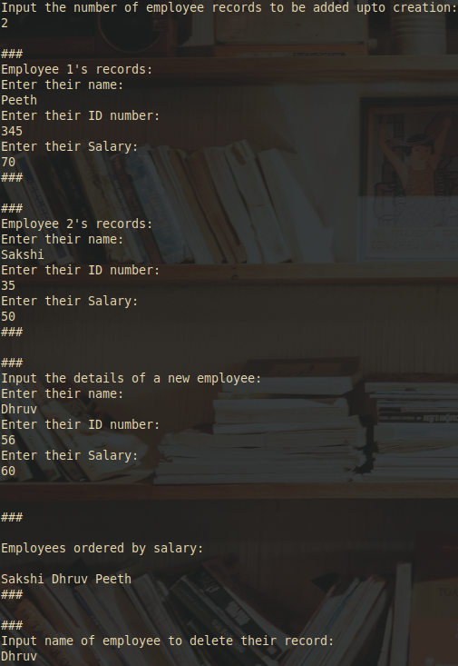
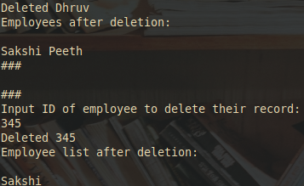
Conclusion:
This experiment teaches us how to use vectors using built-in functions in java.

Date: 26/09/2023 Signature of faculty in-charge

Post Lab Descriptive Questions

- What is the output of the following Program

import java.util.*;
class demo2 {
public static void main(String[] args)
{
Vector v = new Vector(20);
v.addElement("Geeksforgeeks");
v.insertElementAt("Java", 2);
System.out.println(v.firstElement());
}
}

Output:

Exception in thread "main" java.lang.ArrayIndexOutOfBoundsException: 2 > 1
at java.base/java.util.Vector.insertElementAt(Vector.java:620)
at demo2.main(demo2.java:7)

Fix for Error in above Output:
Inorder to remove the above Error the program must be modified as follows:

import java.util.*;
class demo2 {
public static void main(String[] args)
{
Vector v = new Vector(20);
v.addElement("Geeksforgeeks");
v.insertElementAt("Java", 1);
System.out.println(v.firstElement());
}
}

Fixed Program’s Output:
Geeksforgeeks

